**SPECIFICATION FORAPPROVAL**

**MODEL NO：**SC600_JM800WX_01

**Customer：**

|  |  |  |
| --- | --- | --- |
| **Customer approved** | | |
|  |  |  |
| **Feedback ：**  Appearance：□OK，□NG  Effect（view angle，color，brightness）：□OK，□NG  Function：□OK，□NG | | |

|  |  |  |
| --- | --- | --- |
| **J.M.O approved** | | |
| PREPARED | CHECKED | APPROVED |
| Green.Lin |  |  |

JMO Electronics Co.,Ltd

Tel: 0755-82800893

Address:

5th floor, second building, Yijiayang Industrial park, Huaming road,  Dalang street, Longhua new district, Shenzhen

Web：http：//www.jmoopto.com [straight@jmolcd.com](mailto:straight@jmolcd.com)

**Revision List**

|  |  |  |  |
| --- | --- | --- | --- |
| Rev. no | Date | Description | Ref. page |
| 0 | 2020.11.03 | First release |  |
|  |  |  |  |
|  |  |  |  |
|  |  |  |  |
|  |  |  |  |
|  |  |  |  |
|  |  |  |  |
|  |  |  |  |
|  |  |  |  |
|  |  |  |  |
|  |  |  |  |
|  |  |  |  |
|  |  |  |  |
|  |  |  |  |
|  |  |  |  |
|  |  |  |  |
|  |  |  |  |
|  |  |  |  |
|  |  |  |  |
|  |  |  |  |
|  |  |  |  |
|  |  |  |  |

Catalogue

一、 Summary 4

二、 Hardware features 5

三、 Interface description (physical picture) 6

四、 Interface definition 7

1. Pin function described： 7

五、 Transportation, storage and working conditions 11

1. Summary

|  |  |
| --- | --- |
| CPU description | SC600 is a 4G intelligent module based on Qualcomm platform, industrial high performance, running Android operating system, supporting LTLTE-FDD/LTE-TDD/WCDMA/TD-SCDMA/EVDO/CDMA/GSM and other formats; supporting wifi 802.11b/g/n, BT4.1LE short-range wireless communication, support GPS/GLONASS/the dipper multi-standard satellite positioning; Support multiple voice and audio code, integrated AdrenoTM 304 high-performance graphics engine, smooth Play 72720P video; have multiple audio and video input and output interfaces and rich IO interface |
| Interface functions | Quad-core ARM cortex-a53 processor, 1.8ghz, 512KB level 2 cache |
| QDSP6 v5 kernel, working frequency 691.2mhz,768KB L2 cache |
| 8GB EMMC+1Gb LPDDR3 |
| Support DC12V power input |
| Support external hardware clock function, prevent power failure time not saved. |
| Support HP output ,MIC IN and amplifier output |
| Support USB OTG and HOST (compatible design, not available at the same time) |
| Support 100/100m (RJ45) Ethernet |
| Support 1 way RS485 interface |
| On board a TF card slot |
| Support IIC Capacitive touch screen interface |
| Support MIPI digital camera interface |
| Support two-way MIPI LCD interface (compatible design, not available at the same time) |
|  |
|  |
| Display specification | LCD screen size:8寸 |
| Display resolution:800*1280 |
| Display area AA:107.64*172.22（MM） |
| Display mode: always black |
| Display brightness：250 CD/M2 |
| Screen view: full view |
| Touch specification | Capacitive touch |
| 5 fingers touch |
| Meet the finger cover touch |

1. Hardware features

|  |  |  |
| --- | --- | --- |
| CPU and storage unit | CPU | Quad-core ARM cortex-a7 processor, up to 1.8ghz, 512KB level 2 cache |
| memory | 1Gb LPDDR3 |
| storage | 8GB EMMC |
| system | Android 7.1 |
| Data transfer interface | 1 X TF | TF card multimedia storage device (Micro SD connector) (CN13) |
| 2 x USB2.0 HOST | High-speed, 480Mbps(USB A connector) (CN22) |
| 1 X USB2.0 HOST | High-speed, 480Mbps(PH2.0 pitch socket) (CN28) |
| 1 x USB2.0 OTG | High-speed, 480Mbps(MiNI USB connector) (CN29) |
| 1 100M Ethernet port | RTL8152 100MHZ adaptive network port equipment (10M/100M) (CN21) |
| 1 x R485 interface | 1X RS485 interface (CN25) |
| 1 X UART interface | 1 X UART interface, support hardware flow control (CN26) |
| Audio/video signal input/output | 1 X SPK interface | 1X SPK interface 1X3W output (CN16) |
| MIPI - LCD1 interface | A mipi-lcd2 interface, the default driver 8 "screen |
| MIPI - CAM interface | One road MIPI camera interface (CN15) |
| 1 X MIC interface | 1 X MIC interface (CN17) |
| Power supply and  interface | 12V power supply interface | DC12V/2A (4PIN/ 2.0mm socket or DC socket) (CN1) |
|  |  |
|  |  |
|  |  |
| other | GPIO interface | 2.0mm pin GPIO interface (CN24) |
| UBOOT KEY | RECOVERY button (CN5) |
| RESET KEY | System reset key CN2) |
| VIB interface | One way vibrating motor interface (CN23) |
| CTP interface | Capacitor touch screen interface (CN12) |
| SIM card interface | Interface of one SIM card holder (CN14) |
|  | POWER KEY | (CN10) |
|  |  |  |

1. Interface description (physical picture)

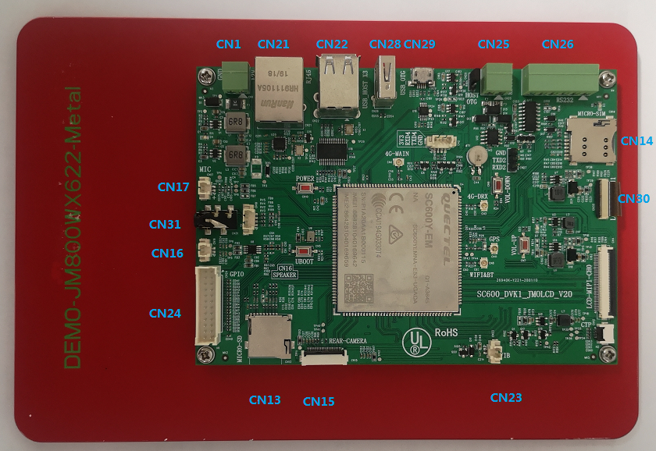

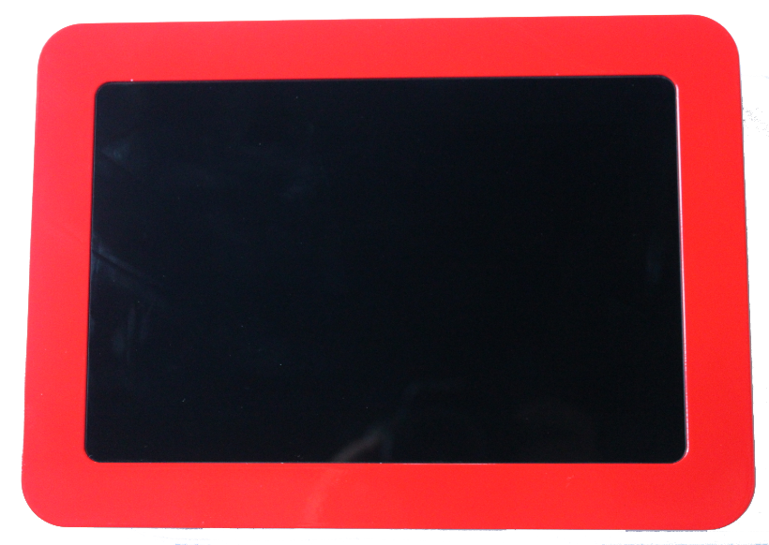

1. Interface definition
2. Interface definition description：

|  |  |  |  |
| --- | --- | --- | --- |
| **CN23: Vibrator interface (2PIN/1.25MM Pitch WAFER)** | | |  |
| NO. | SYMBOL | DESCRIPTION |  |
| 1 | VDD_3V | VDD_3V |  |
| 2 | VIB_DRV_IN | VIB_DRV_IN |  |
| **CN5: key interface (6PIN/1.25MM Pitch WAFER)** | | | |
| NO. | SYMBOL | DESCRIPTION |  |
| 1 | KEY_HOME | KEY_HOME |  |
| 2 | KEY_MENU | KEY_MENU |  |
| 3 | KEY_VOL_UP | KEY_VOL_UP |  |
| 4 | KEY_VOL_DOWN_KF_N | KEY_VOL_DOWN_KF_N |  |
| 5 | PWRKEY | PWRKEY |  |
| 6 | GND | GND |  |
| **CN14: SPK horn interface(2PIN/1.25MM Pitch WAFER)** | | | |
| NO. | SYMBOL | DESCRIPTION |  |
| 1 | SPKP | SPKP |  |
| 2 | SPKN | SPKN |  |
| **CN17: MIC horn interface(2PIN/1.25MM Pitch WAFER)** | | |  |
| NO. | SYMBOL | DESCRIPTION |  |
| 1 | MICP | MICP |  |
| 2 | MICN | MICN |  |
| **CN25：MIPI camera interface(25PIN/0.5MM Pitch FPC)** | | | |
| NO. | SYMBOL | DESCRIPTION |  |
| 1 | GND | GND |  |
| 2 | CLKP | CLKP |  |
| 3 | CLKN | CLKN |  |
| 4 | GND2 | GND2 |  |
| 5 | DP1 | DP1 |  |
| 6 | DN1 | DN1 |  |
| 7 | GND | GND |  |
| 8 | DP0 | DP0 |  |
| 9 | DN0 | DN0 |  |
| 10 | GND | GND |  |
| 11 | MCLK | MCLK |  |
| 12 | GND | GND |  |
| 13 | RESET | RESET |  |
| 14 | PWDN1 | PWDN1 |  |
| 15 | GND | GND |  |
| 16 | AVDD28 | AVDD28 |  |
| 17 | GND | GND |  |
| 18 | I2C_SDA | I2C_SDA |  |
| 19 | I2C_SCL | I2C_SCL |  |
| 20 | GND | GND |  |
| 21 | DVDD18 | DVDD18 |  |
| 22 | GND | GND |  |
| 23 | DOVDD18 | DOVDD18 |  |
| 24 | AF_VDD28 | AF_VDD28 |  |
| **CN1: POWER IN interface DC12V (2PIN/3.81MM connection terminal)** | | | |
| NO. | SYMBOL | DESCRIPTION |  |
| 1 | VDD_IN | DC12V power |  |
| 2 | GND | GND |  |
| **CN20:PIO interface (20PIN/2MM spacing double row with buckle)** | | |  |
| NO. | SYMBOL | DESCRIPTION |  |
| 1 | VDD_5V | VDD_5V |  |
| 2 | VDD_1V8 | VDD_1V8 |  |
| 3 | VDD_3V3 | VDD_3V3 |  |
| 4 | GND | GND |  |
| 5 | SC20_GPIO_16 | SC20_GPIO_16 |  |
| 6 | SC20_GPIO_95 | SC20_GPIO_95 |  |
| 7 | SC20_GPIO_9 | SC20_GPIO_9 |  |
| 8 | SC20_GPIO_94 | SC20_GPIO_94 |  |
| 9 | SC20_GPIO_96 | SC20_GPIO_96 |  |
| 10 | SC20_GPIO_36 | SC20_GPIO_36 |  |
| 11 | SC20_GPIO_31 | SC20_GPIO_31 |  |
| 12 | SC20_GPIO_92 | SC20_GPIO_92 |  |
| 13 | SC20_GPIO_97 | SC20_GPIO_97 |  |
| 14 | SC20_GPIO_89 | SC20_GPIO_89 |  |
| 15 | SC20_GPIO_88 | SC20_GPIO_88 |  |
| 16 | SC20_GPIO_68 | SC20_GPIO_68 |  |
| 17 | SC20_GPIO_98 | SC20_GPIO_98 |  |
| 18 | SC20_GPIO_69 | SC20_GPIO_69 |  |
| 19 | SC20_GPIO_32 | SC20_GPIO_32 |  |
| 20 | GND | GND |  |
|  |  |  |  |
| **CN25:RS485 interface (2PIN/ 3.81mm connection terminal)** | | |  |
| NO. | SYMBOL | DESCRIPTION |  |
| 1 | RS485B | RS485B |  |
| 2 | RS485A | RS485A |  |
| **CN30: mipi-lcd2 LCD interface 7-inch (39PIN/ 0.3mm spacing FPC seat)** | | | |
| NO. | SYMBOL | DESCRIPTION |  |
| 1 | VLED1 | VLED1 |  |
| 2 | VLED2 | VLED2 |  |
| 3 | NC1 | NC1 |  |
| 4 | FB1 | FB1 |  |
| 5 | FB2 | FB2 |  |
| 6 | FB3 | FB3 |  |
| 7 | ID | ID |  |
| 8 | CTP_RST | CTP_RST |  |
| 9 | CTP_INT | CTP_INT |  |
| 10 | CTP_SDA | CTP_SDA |  |
| 11 | CTP_SCL | CTP_SCL |  |
| 12 | GND | GND |  |
| 13 | TP-VDDH | TP-VDDH |  |
| 14 | TP-VBUS | TP-VBUS |  |
| 15 | GND2 | GND |  |
| 16 | MIPI_RESET | MIPI_RESET |  |
| 17 | LEDPWM | LEDPWM |  |
| 18 | NC4 | NC4 |  |
| 19 | VPP | VPP |  |
| 20 | NC5 | NC5 |  |
| 21 | GND3 | GND |  |
| 22 | 3V3 | 3V3 |  |
| 23 | 3V3 | 3V3 |  |
| 24 | GND4 | GND |  |
| 25 | MIPI_D0N | MIPI_D0N |  |
| 26 | GND5 | GND |  |
| 27 | MIPI_D0P | MIPI_D0P |  |
| 28 | MIPI_D1N | MIPI_D1N |  |
| 29 | GND6 | GND |  |
| 30 | MIPI_D1P | MIPI_D1P |  |
| 31 | MIPI_CLKN | MIPI_CLKN |  |
| 32 | GND7 | GND |  |
| 33 | MIPI_CLKP | MIPI_CLKP |  |
| 34 | MIPI_D2N | MIPI_D2N |  |
| 35 | GND8 | GND |  |
| 36 | MIPI_D2P | MIPI_D2P |  |
| 37 | MIPI_D3N | MIPI_D3N |  |
| 38 | GND9 | GND |  |
| 39 | MIPI_D3P | MIPI_D3P |  |
| 39 | MIPI_D3P | MIPI_D3P |  |

1. Transportation, storage and working conditions
   * 1. Preservation environment: anti-static, moisture-proof and anti-backlog
     2. Input voltage：DC 12V

3.Working environment temperature：0 ~ 60℃

4.Relative humidity：20% ~ 70%

5.Storage environment temperature：-20~ 60℃